**Q1 - Take 2 integer values in two variables x and y and print their product.** (Easy)

Sample Input : x=2, y=4 (Both integers)

Sample Output : 8

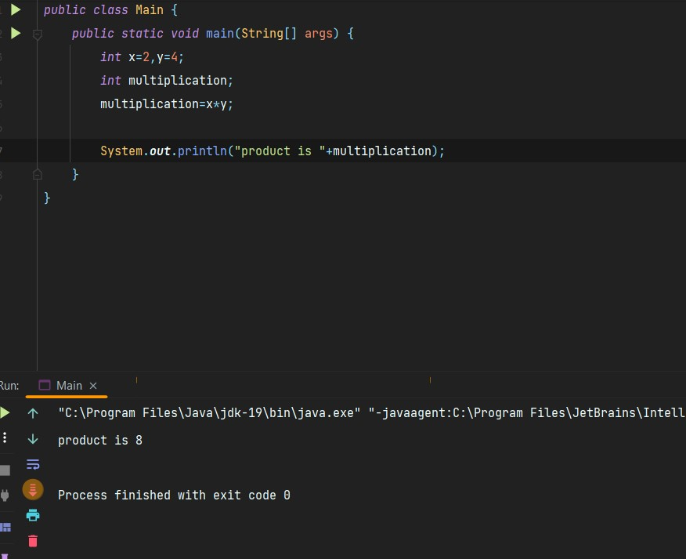

**Q2 - Print the ASCII value of character ‘U’.** (Easy)

Sample Input : already mentioned as ‘U’

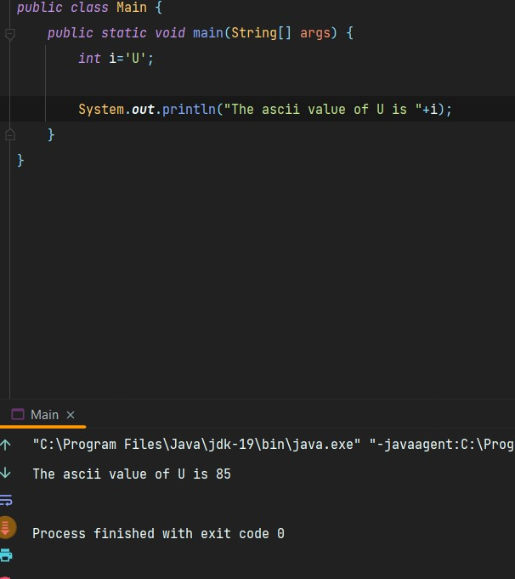Sample Output : 85

**Q3 - Write a Java program to take the length and breadth of a rectangle and print its area.** (Easy)

Sample Input : 7, 4

Sample Output : 28

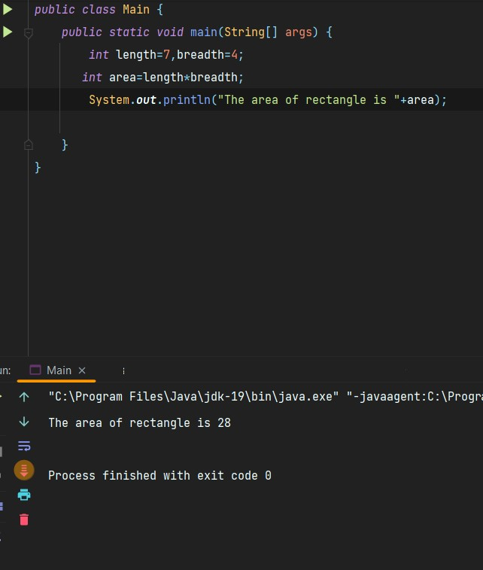

**Q4 - Write a Java program to calculate the cube of a number.** (Easy)

Sample Input : 4

Sample Output : 64

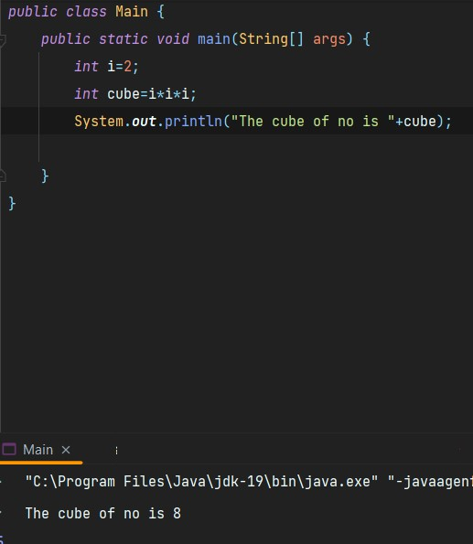The sizeof(bool) : 1 bytes

**Q5 - Write a Java program to swap two numbers with the help of a third variable.**

(Hard)

Sample Input : 2,3

Sample Output : 3,2

